Exp 1:

-I’m running FIMTool on “Tustin_12B.slx”. With fault injection list like below, it did not inject any faults into the model. 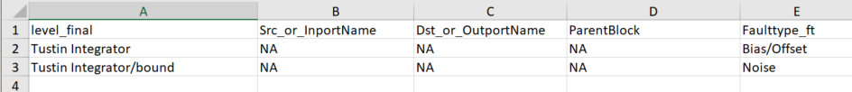

Then I realized that it won’t throw any error if “level_final” is wrong.

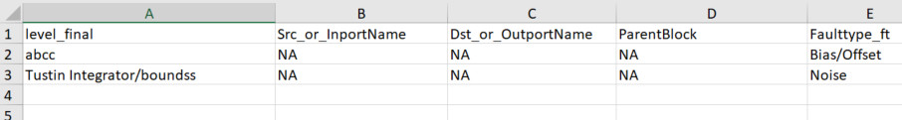

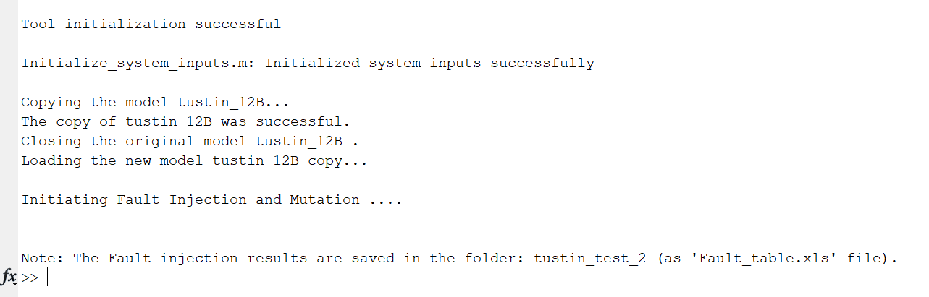

Then I checked the way they write down the “level_final” in Autotrans model:

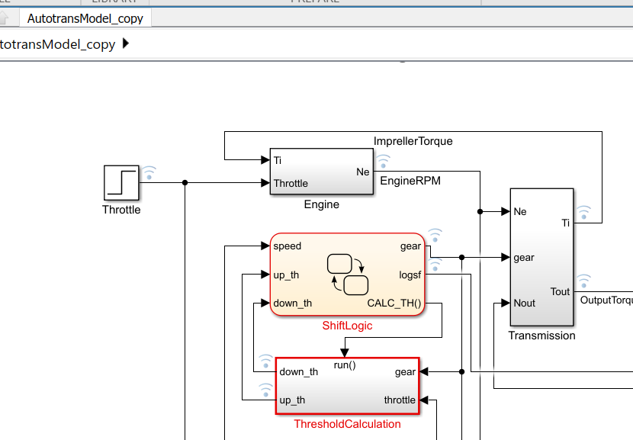 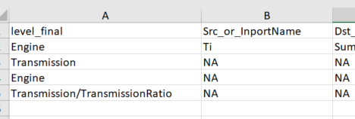

It was just like the way I write it, but looks like mine does not work!

I went through the code for a couple of hours and try to find where is the difference between my model and the “Autotrans” model, but it did not workout.

Exp 2:

I changed the “fault injection list” this way:



This way the tool injects some faults and suddenly stops with the following error:

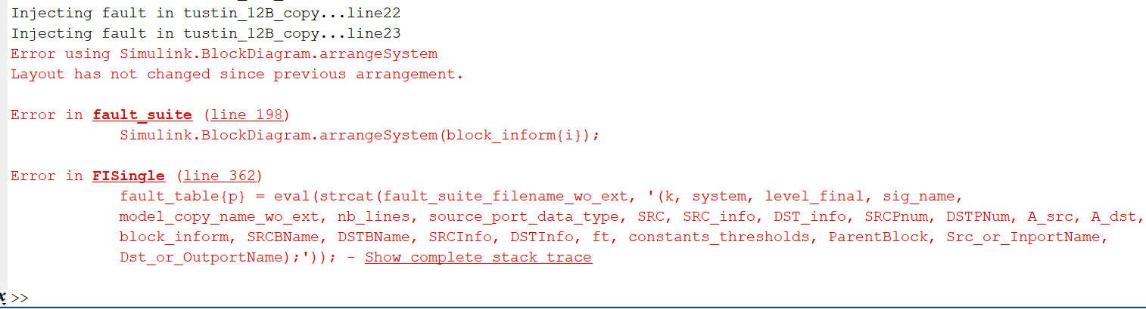

(Also, is only works when I open MATLAB freshly! I mean when I run it again, the tool stops at the very first fault and gives this error:

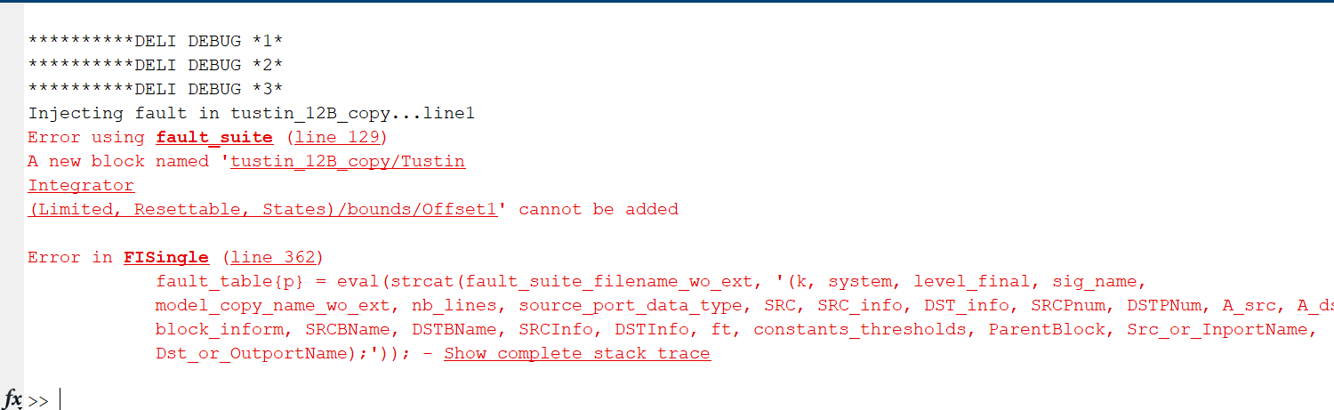

But when I close MATLAB and re-open it, it will work as I mentioned above. (I tried deleting the …._copy.slx file, doesn’t work!))